Stainless Steel 316 Stress Corrosion Cracking System
Technical Design, Operations, and Maintaince Manual
Document Number: SCC-TDM-001
Revision: 0.1 Draft
Author: John Jin
Date: June 9, 2026

Revision History:
Revision | Date | Author | Description
0.1 | June 9, 2026 | John Jin | Initial Draft

Table of Contents
1. Introduction 5
1.1. Purpose 5
1.2. Scope 6
1.3. Objectives 6
2. System Overview 7
2.1. Functional Requirements 7
2.2. Performance Requirements 7
3. System Overview 8
3.1. Architecture 8
3.2. Hardware Components 9
3.3. Software Components 9
4. Hardware Design 10
4.1. Hardware Block Diagram 10
4.2. Sensor System 12
4.3. Shield Circuit 12
5. Software Design 17
5.1. Firmware Architecture 17
5.2. Operating States 17
5.3. Event Codes 19
5.4. MQTT Topics 19
6. Database Design 20
6.1. Database Overview 20
6.2. Process Data Table 21
6.3. Supporting Tables 22
6.4. Relationships 23
6.5. Data Indexing Strategy 23
6.6. Data Retention Policy 24
7. Control System Design 25
7.1. Control Objectives 25
7.2. Current Control Architecture 25
7.3. Control Modes 26
7.4. Safety Logic 26
7.5. Pump Aware Compensation. 27
7.6. Advisory Model Predictive Control (MPC) 27
7.7. Machine Learning Roadmap 28
8. Safety Analysis 30
8.1. Hazards 30
8.2. Safety Features 31
8.3. Emergency Shutdown Procedure 32
8.4. Safety verification Tests 32
8.5. Residual Risk and Recommendation 33
9. Verification and Validation 35
9.1. Verification and Validation Overview 35
9.2. Unit Tests 35
9.3. Integration and Hardware Validation Procedures 37
9.4. Current Verification Coverage Gaps 38
9.5. Verification Summary 39
10. Deployment Guide 40
10.1. Deployment Overview 40
10.2. Server Requirements 40
10.3. Containerized Services 41
10.4. Deployment Procedure 41
10.5. Post-Deployment Verification 43
11. Operations Guide 44
11.1. Startup Procedure 44
11.2. Corrosive Medium Preparation and Handling 44
11.3. Operator Responsibilities and Monitoring Requirements 45
Operator Responsibilities 45
Monitoring Requirements 45
11.4. Alarm Response Procedures 46
11.5. Shutdown Procedure 47
12. Maintenance Manual 48
12.1. Maintenance Overview 48
12.2. Preventive Maintenance 48
12.3. Corrective Maintenance 49
12.4. Component Replacement Guidelines 50
12.5. Maintenance Safety Considerations 50
13. Troubleshooting Guide 52
13.1. Troubleshooting Overview 52
13.2. Troubleshooting Workflow 55
13.3. Escalation Criteria 56
14. References 57

Introduction

Purpose
The Stress Corrosion Cracking (SCC) test system is an automated control system designed to heat the specimen and pump corrosive medium, such as magnesium chloride (MgCl2), while the sample undergoes creep loading. The platform integrates embedded hardware, process control algorithms, wireless communication, database infrastructure, and data analysis into a unified architecture [1–10].
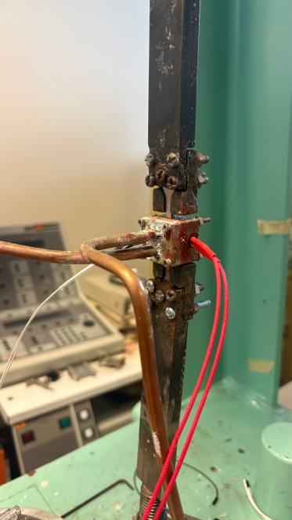
Fig 1. Testing setup

Scope
This document will include the following facets of the system:
- System architecture
- Hardware design
- Firmware design
- Backend infrastructure
- Database structure
- Control algorithms
- Safety systems
- Testing procedures
- Operational procedures

Objectives
The primary objectives of the SCC platform are:
- Reliable process
The system must be designed to repeat the experiment process repeatedly. This process should be capable of being repeated with minimal human intervention to address any potential issues that may arise.
- Reliable monitoring method
The system must be monitored with ease and reliability. All sensors must remain operational for an extended period beyond the duration of a single testing experiment.
- Automated test control (temperature, pump frequency, etc.)
The PID system should be equipped with self-tuning capabilities and housed in a secure environment.
- Safe heater operation
The temperature should not exceed 20 degrees Celsius above the set point or 350 degrees Celsius.
- Continuous data logging
It’s important to log crucial parameters, including temperature, pump cycle, and time, in CSV format. These parameters encompass any data required for stress corrosion testing analysis, physics-informed machine learning models, or digital twins.
- Remote monitoring capability
The parameters of the heater and pump should be adjustable remotely via the cloud. Firmware for both ESP32 and Arduino Uno R3 should support Over the Air (OTA) updates. Additionally, the Kill Command should also be executed via OTA.

System Requirements
This system is employed for conducting stress corrosion cracking experiments. It provides heating and a corrosive medium for the dog-bone samples during creep loading. The cartridge heater enables users to set the desired temperature, while the peristaltic pump propels MgCl₂ (corrosive medium) through the copper pipes and cells, exposing the samples to the corrosive environment. The entire system should function in a quasi-automated mode.
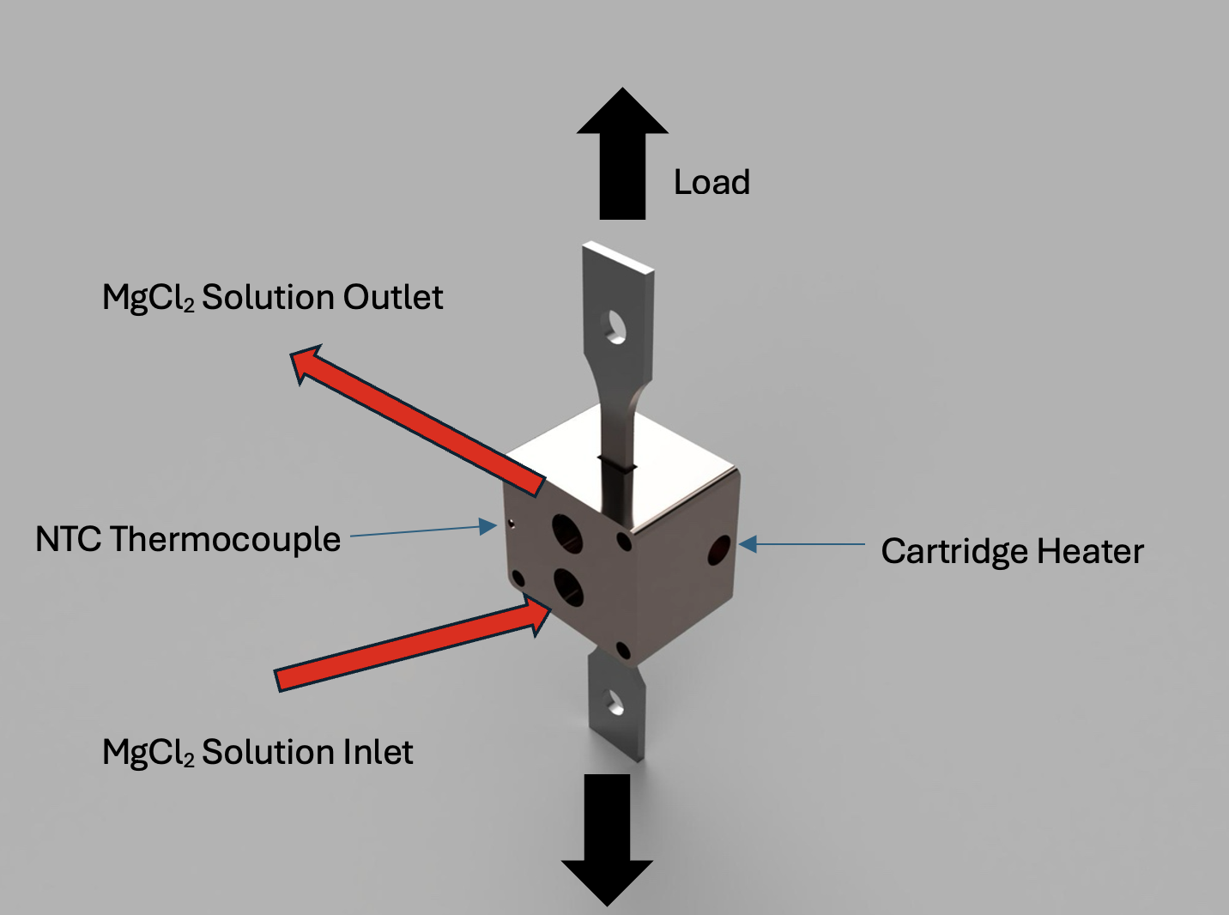
Fig 2. The hardware schematic of the system

Functional Requirements
ID | Requirement
FR-001 | Measure system temperature
FR-002 | Control heater output
FR-003 | Control pump circulations
FR-004 | Log data
FR-005 | Provide a method to monitor remotely
FR-006 | Execute safety shutdowns
Table 1. List of required functions for the system to perform

Performance Requirements
ID | Requirement | Target
PR-001 | Telemetry update rate | 1Hz
PR-002 | Data retention | ≥ 1 year
PR-003 | Uptime | >99%
PR-004 | Network Latency | <2 s
Table 2. List of performance targets the system needs to achieve

System Overview

Architecture
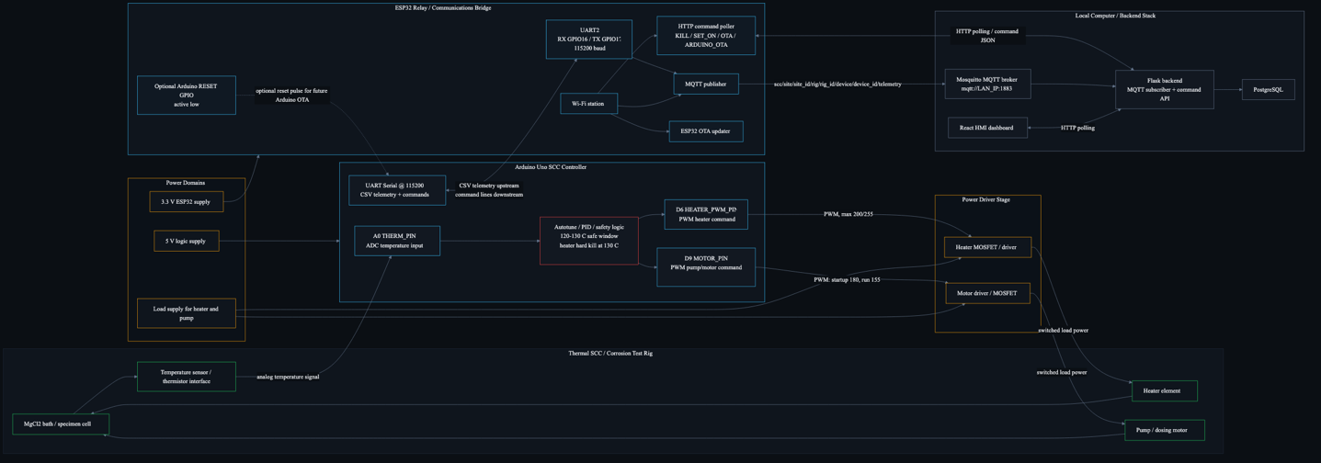
Fig 3. End-to-end system architecture
Fig 3 illustrates the end-to-end architecture of the SCC testing platform. The NTC thermistor and cartridge heater interface with the Arduino controller, which performs local control and data acquisition functions using the hardware components summarized in Table 3. The Arduino communicates with an ESP32 module that serves as a telemetry and command relay between the field hardware and backend infrastructure.
Sensor measurements, process data, and control messages are transmitted through the MQTT broker to the Flask API, which acts as the central integration layer for data management, command processing, analytics, and operator interaction. The software components that support these functions are summarized in Table 4. Processed data are stored in a PostgreSQL database, enabling long-term data retention, historical analysis, and performance monitoring.
The backend provides additional services, including alarm generation, pump-cycle extraction, machine-learning-based prediction, and advisory Model Predictive Control (MPC). Real-time communication between the backend and operator interface is implemented using a Socket.IO event bus [10]. This continuously updates the Human–Machine Interface (HMI) dashboard with process status, alarms, trends, and operator recommendations.
Operator-issued commands are routed through the Flask API and command store to the ESP32 command bridge, enabling remote actuation and over-the-air (OTA) firmware deployment. By separating field control, data acquisition, analytics, data storage, and user interaction into modular subsystems, the proposed architecture improves system scalability, maintainability, reliability, and future extensibility.

Hardware Components
The SCC testing platform consists of several hardware subsystems responsible for sensing, actuation, control, and communication. The primary hardware components and their functions are summarized in Table 3.

Component | Function
Arduino | Embedded controller
ESP32 | Telemetry and command relay
Thermistor | Temperature measurement
Cartridge heater | Thermal control
Pump | Fluid Circulation
SCC Shield | Power switching
Table 3. List of hardware in the system
  - Software Components
The software architecture is organized into modular services responsible for control, communication, data management, and user interaction using MQTT, Flask, PostgreSQL, Socket.IO, and Docker technologies [1,4–10]. The major software components used in the SCC platform are summarized in Table 4.

Components | Function
Arduino Firmware | Local Control
ESP32 Firmware | Relay telemetry and commands
MQTT Broker | Messaging
Flask API | Backend services
Flask Server | Data Login and HMI interface
PostgreSQL | Data Storage
Dashboard | User interface HMI
Table 4. List of software tools used in the system

Hardware Design

Hardware Block Diagram
Fig 4 shows the hardware block diagram of the SCC testing platform. The system is centered around an Arduino UNO R3 microcontroller, which executes the local temperature control and pump management logic. The Arduino interfaces with a custom SCC Shield that provides sensor acquisition, power switching, and hardware interfacing functions. An NTC thermistor is connected to the SCC Shield for temperature measurement, while a cartridge heater and peristaltic pump are controlled through the shield to regulate the thermal and fluid circulation conditions of the SCC test environment. An ESP32 module serves as a communication bridge between the embedded controller and the supervisory control system. Through a Wi-Fi connection, the ESP32 exchanges telemetry and control commands with a remote Flask server, enabling real-time monitoring, data logging, and remote operation of the testing platform. This architecture separates local control functions from supervisory communication tasks, improving system modularity, maintainability, and scalability.

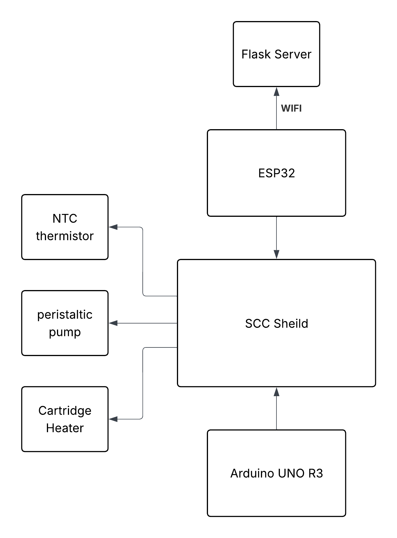
Fig 4. Hardware Block Diagram of the SCC Testing Platform
- Arduino Uno R3
Purpose: The Arduino Uno R3 serves as the primary embedded controller for the SCC testing platform and is based on the ATmega328P microcontroller architecture [3,15]. It acquires temperature measurements from the NTC thermistor, executes local control logic, manages heater and pump operation, and communicates process data to the ESP32 communication module.

Key Spec:
  - Microcontroller: ATmega328P
  - Operating Voltage: 5 V
  - Clock Speed: 16 MHz
  - Digital I/O Pins: 14
  - Analog Input Channels: 6
  - Communication Interfaces: UART, I²C, SPI

Firmware version: SCC V1.4

- ESP32
Purpose: The ESP32 functions as the communication bridge between the embedded control hardware and the supervisory control system using integrated Wi-Fi communication capabilities [2]. It receives telemetry data from the Arduino, publishes process information through MQTT, receives remote commands, and supports over-the-air (OTA) firmware updates.

Key Spec:
  - Processor: Dual-core Xtensa LX6
  - Clock Speed: Up to 240 MHz
  - Wireless Connectivity: 2.4 GHz Wi-Fi and Bluetooth
  - Flash Memory: 4 MB
  - Communication Interfaces: UART, SPI, I²C

Firmware version: ESP32-Relay

- Intel NUC
Purpose: The Intel NUC serves as the local supervisory computer hosting the Flask backend, MQTT broker, PostgreSQL database, and analytics services [14], MQTT broker, PostgreSQL database, data historian, alarm processing services, machine learning models, and Human–Machine Interface (HMI).

Key Spec:
  - Processor: Intel Core Series Processor
  - Operating System: Ubuntu Linux 24.04 LTS
  - Memory: 8 GB DDR4 RAM
  - Storage: 125 GB SSD
  - Network Connectivity: Gigabit Ethernet and Wi-Fi

Firmware version: SCC Control V0.1.1.4

  - Sensor System
- Temperature Sensor:
Type: Negative Temperature Coefficient (NTC) Thermistor
Purpose:
The NTC thermistor provides continuous temperature measurement of the SCC test environment. The Arduino controller uses the sensor to regulate heater operation, monitor process conditions, and provide temperature feedback for data logging and future advanced control applications.

Sampling Method:
Analog voltage measurement through the Arduino Uno R3 analog-to-digital converter (ADC).

Shield Circuit
Overview of system shield design:
The SCC Shield is a custom-designed interface and power-control board that serves as the hardware integration layer between the Arduino Uno R3 and the SCC test rig components. The shield provides sensor signal conditioning, power distribution, and actuator control functions required for automated operation of the corrosion testing platform. Temperature measurements from the NTC thermistor are routed through an analog conditioning circuit and supplied to the Arduino’s analog-to-digital converter (ADC) for real-time temperature monitoring. High-current switching circuitry on the shield enables the Arduino to safely control the cartridge heater and peristaltic pump using low-voltage digital control signals. The shield also provides electrical isolation between low-power control electronics and higher-power load circuits, improving system reliability and protecting the microcontroller from electrical transients generated by inductive loads.

In addition to power-switching functionality, the SCC Shield consolidates wiring connections into a single interface board, simplifying system assembly, maintenance, and troubleshooting. The modular design allows sensors, actuators, and communication hardware to be connected through standardized connectors while maintaining compatibility with the Arduino platform. This architecture reduces wiring complexity and provides a scalable foundation for future expansion of sensing, control, and data acquisition capabilities.

Schematic:

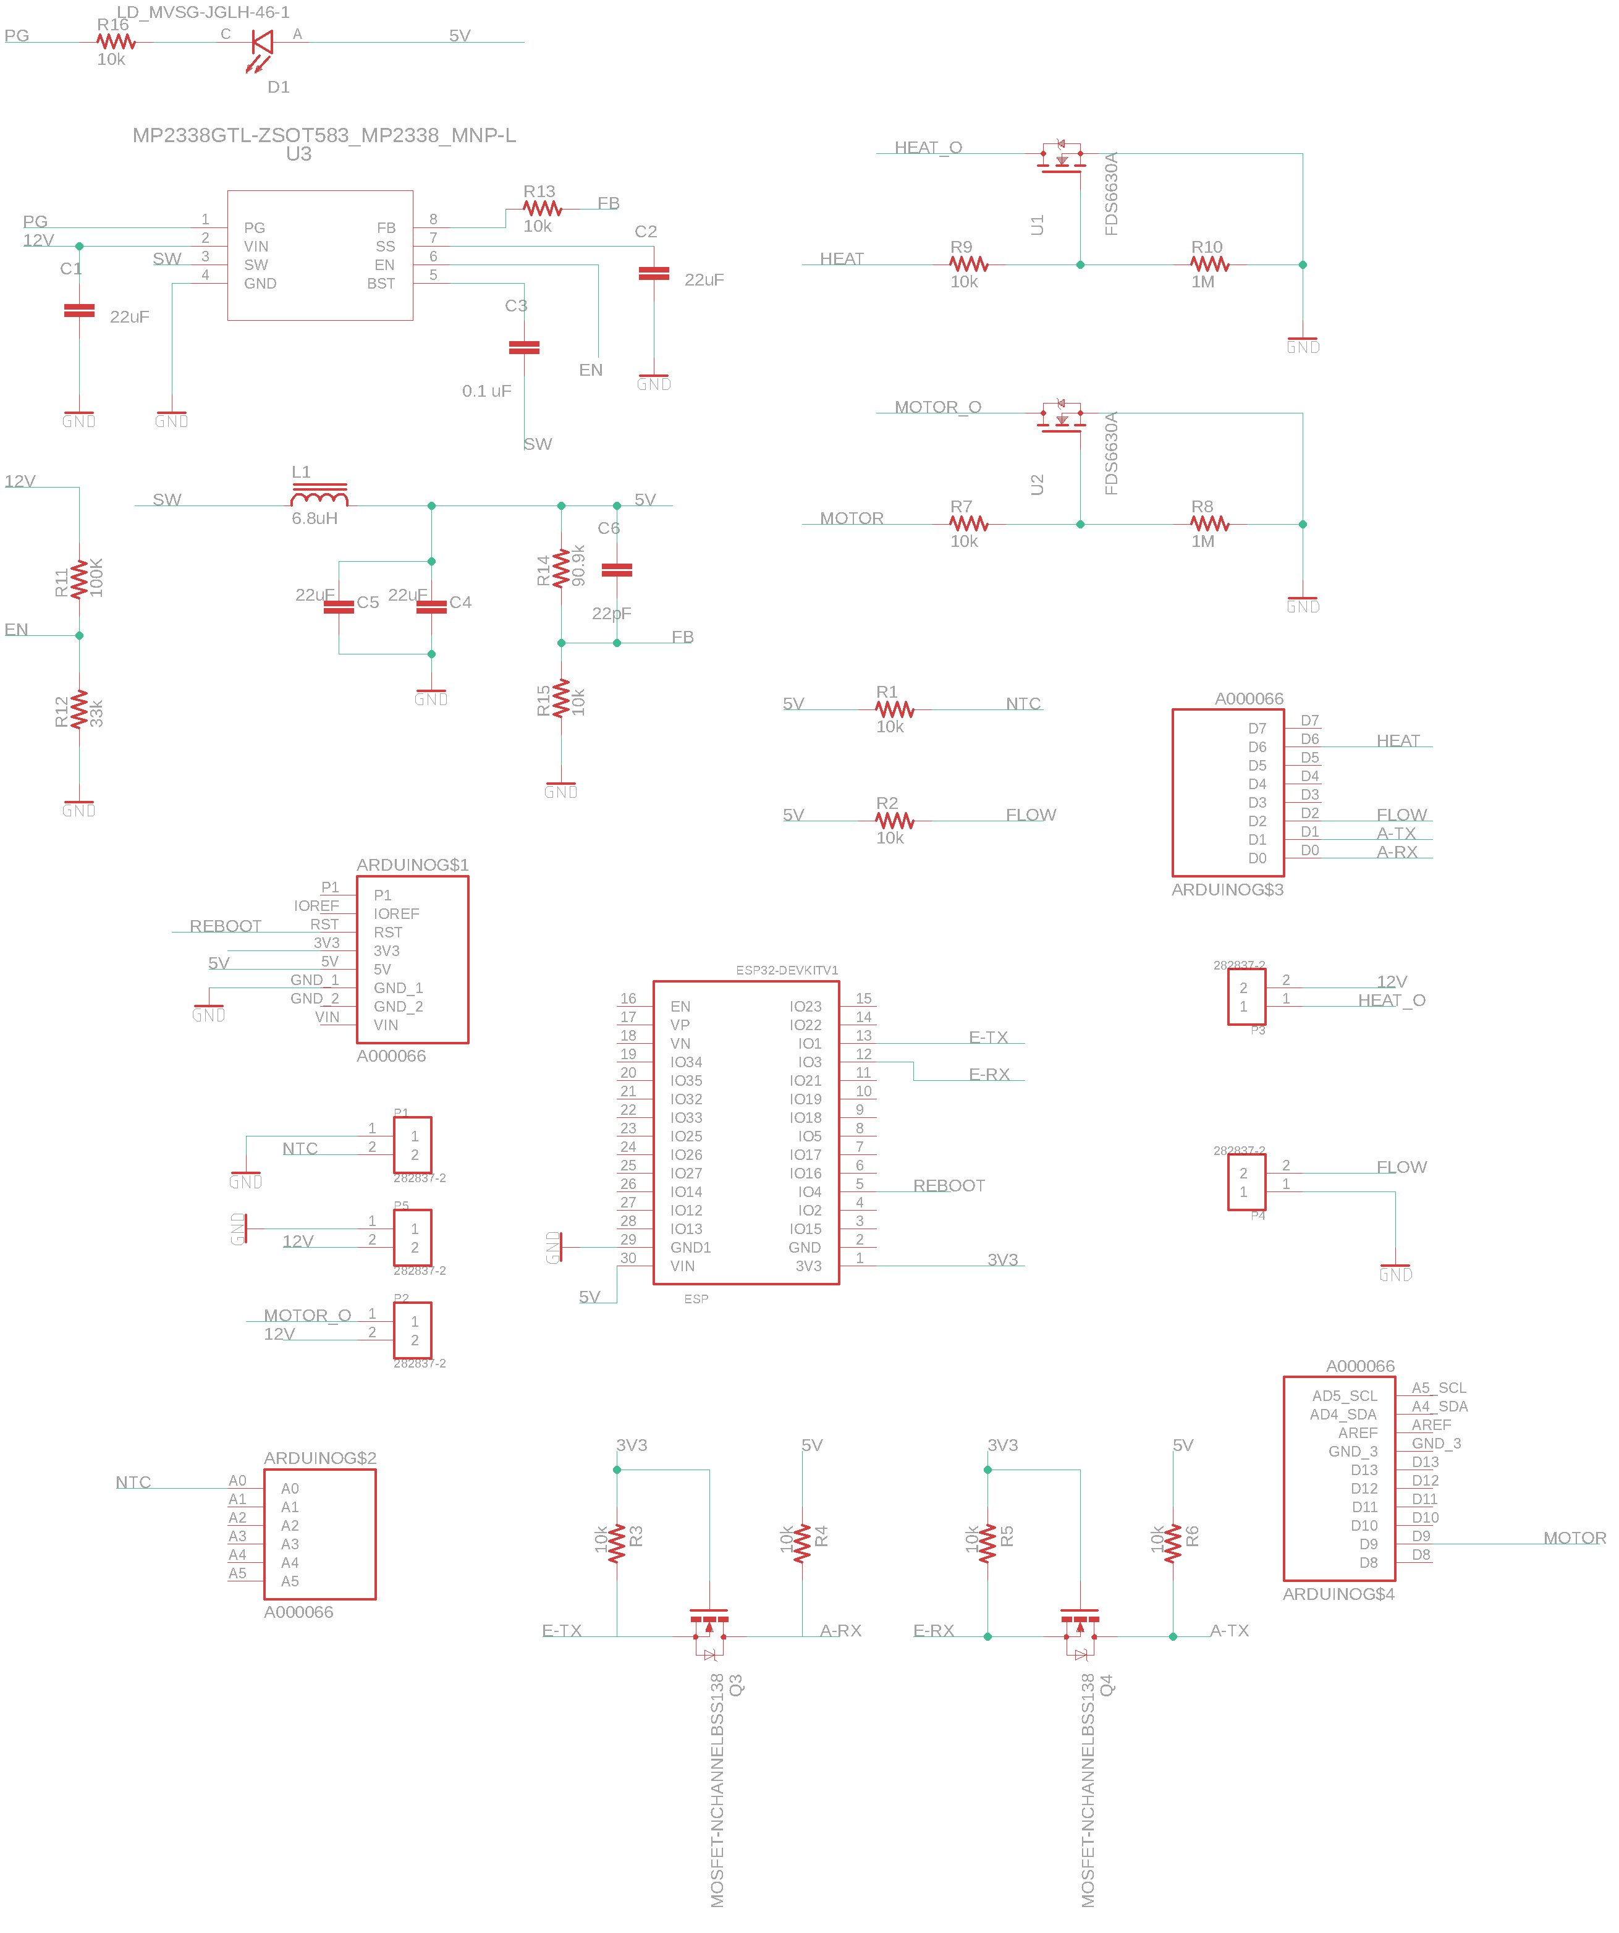
Fig 5. SCC Shield Electrical Schematic

Board Layout:

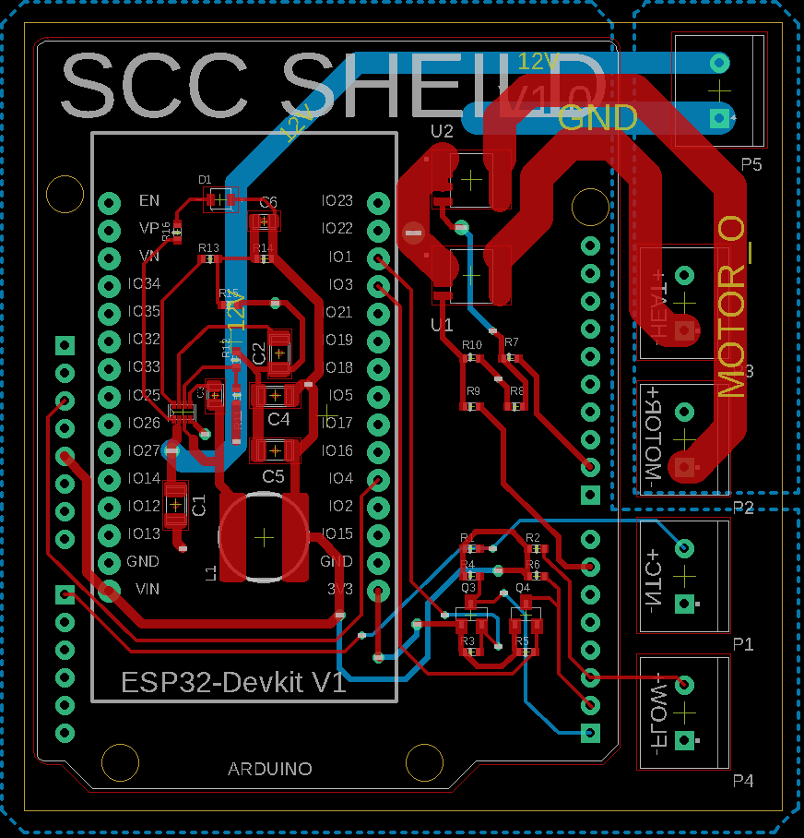
Fig 6. SCC shield board layout
- Heater Control Circuit
Description:
The heater control circuit provides low-side switching of the cartridge heater using an N-channel MOSFET (U1, FDS6630A). A digital output from the Arduino drives the MOSFET gate through a 10 kΩ gate resistor (R9), allowing the microcontroller to enable or disable heater power. A 1 MΩ pull-down resistor (R10) ensures that the MOSFET remains off during startup, reset conditions, or when the control signal is disconnected. The heater is supplied from the 12 V power rail and is switched under software control to maintain the desired SCC test temperature. This configuration provides efficient switching with minimal power dissipation while electrically isolating the microcontroller from the heater load current.

Operating Voltage: 12 VDC

Maximum Current: Determined by MOSFET rating and power connector limitations

Switching Method: Digital low-side MOSFET switching

Protection Features:
  - Gate pull-down resistor to prevent unintended activation
  - Logic-level MOSFET operation
  - Separation of control and power paths
  - Pump Control Circuit
- Pump Control Circuit
Description:
The pump control circuit uses a second N-channel MOSFET (U2, FDS6630A) to control power delivery to the peristaltic circulation pump. The Arduino drives the MOSFET gate through resistor R7, while pull-down resistor R8 maintains the MOSFET in an off state when no control signal is present. The pump receives power from the 12 V supply and is activated periodically according to the SCC control algorithm to circulate solution through the test apparatus. The MOSFET-based design enables reliable switching while minimizing mechanical wear associated with relay-based control methods.

CAUTION: Use a minimum 14 AWG wire for all motor power connections. The peristaltic pump can draw significant startup and operating current, and undersized wiring may result in excessive voltage drop, overheating, reduced motor performance, or potential damage to wiring and connectors.

Operating Voltage: 12 VDC

Current Draw: Dependent on pump operating conditions

Switching Method: Digital low-side MOSFET switching

Protection Features:
  - Gate pull-down resistor to prevent unintended activation
  - Logic-level MOSFET operation
  - Dedicated power routing for actuator loads

Software Design

Firmware Architecture
Fig 7 presents the operating state machine implemented within the SCC testing platform firmware. The control logic is organized into six primary operating states: Startup, Idle, Heating, Pumping, Lockout, and Emergency Shutdown. Measured temperature, user-defined setpoints, pump scheduling requirements, and safety conditions determine state transitions. During normal operation, the controller transitions from Startup to Idle, where system readiness is verified. When the measured temperature falls below the configured setpoint, the controller enters the Heating state and activates the cartridge heater. Once the target temperature is reached, the system returns to Idle and periodically executes Pumping cycles to circulate the test solution. Safety monitoring is continuously active throughout all operating states. If an abnormal temperature drop is detected following a pump cycle, the controller enters Lockout mode to prevent ineffective heating and excessive actuator cycling. Critical faults, including excessive temperature, sensor failure, or manual emergency stop commands, force the system into Emergency Shutdown mode, where all outputs are disabled until operator intervention occurs. This state-based architecture improves system reliability, predictability, and operational safety by clearly separating normal control functions from fault-handling behavior.

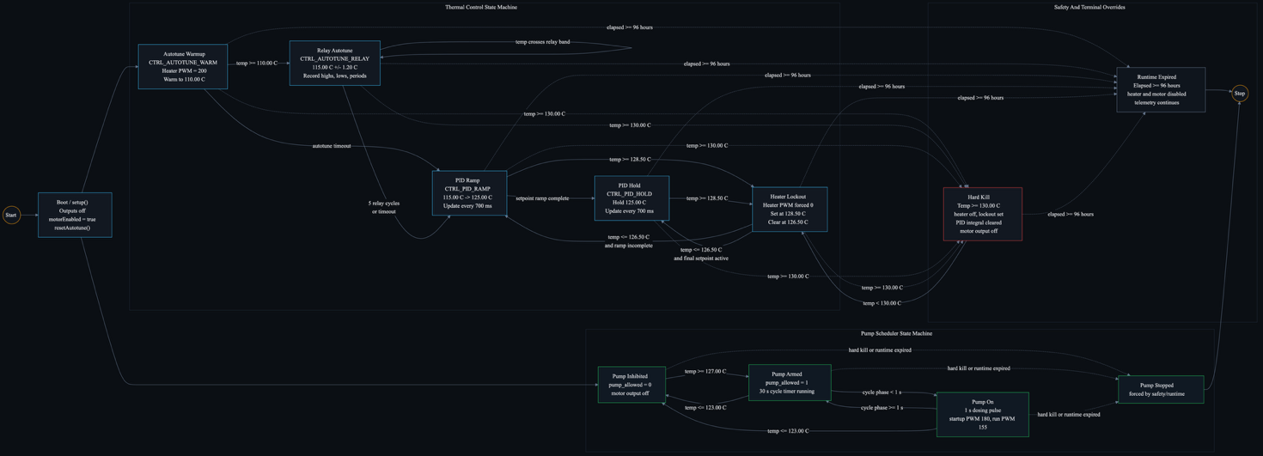
Fig7. SCC Control State Machine Annotation

Operating States
  - Startup
The Startup state is entered immediately after power-up or system reset. During this phase, the controller initializes hardware peripherals, verifies sensor communication, loads configuration parameters, and establishes communication with the ESP32 telemetry module. All outputs remain disabled until initialization is successfully completed. Upon successful startup, the controller transitions to the Idle state.
  - Idle
The Idle state represents the normal standby operating condition. In this state, the controller continuously monitors process temperature, evaluates pump scheduling timers, and checks safety conditions while maintaining all actuators in a safe state. If the measured temperature falls below the desired setpoint, the system transitions to the Heating state. If a scheduled circulation cycle is required and operating conditions permit, the controller transitions to the Pumping state.

  - Heating
The Heating state regulates the cartridge heater to raise the process temperature toward the user-defined setpoint. Temperature measurements from the NTC thermistor are continuously monitored to prevent overheating and ensure stable thermal control. When the target temperature is achieved, the heater is disabled and the controller returns to the Idle state. Safety monitoring remains active throughout the heating process.

  - Pumping
The Pumping state activates the circulation pump for a predefined duration to ensure fluid mixing and representative temperature measurements. During pump operation, the controller records thermal response characteristics, including temperature drop and recovery behavior. Upon completion of the pump cycle, the system returns to the Idle state. If abnormal cooling or unsafe operating conditions are detected, the controller may transition to the Lockout or Emergency Shutdown state.

  - Lockout
The Lockout state is a protective operating mode used to prevent repeated heating and pumping cycles under unfavorable conditions. Lockout may be triggered when the temperature fails to recover adequately after a pump cycle or when operating limits defined by the control strategy are exceeded. While in Lockout, heater and pump operations are restricted until acceptable process conditions are restored. Once recovery criteria are met, the controller automatically returns to the Idle state.

  - Emergency Shutdown
The Emergency Shutdown state is the highest-priority safety state. It is entered whenever a critical fault condition is detected, such as excessive temperature, sensor failure, communication failure, hardware fault, or a manual emergency stop command. Upon entry, all actuators are immediately disabled and an emergency event is logged and transmitted to the backend system. Recovery from Emergency Shutdown requires operator acknowledgement and corrective action before normal operation can resume.

Event Codes
The SCC firmware records key operational events using a standardized event-code system to support data logging, diagnostics, and backend analytics. Each event is transmitted through the telemetry interface and stored within the database, allowing system behavior to be reconstructed during testing and fault investigation. The event codes used by the platform are summarized in table 5.

Code | Event
0 | Normal Sample
1 | Pump start
2 | Pump end
3 | Recovery complete
4 | Hard kill
Table 5. Event codes generated by the SCC firmware for operational logging and system monitoring.

MQTT Topics
MQTT serves as the primary messaging layer between the ESP32 gateway and the backend infrastructure and enables lightweight publish-subscribe communication for industrial telemetry applications [1,7]. Topic namespaces are structured using site, rig, and device identifiers to support multi-device deployments and simplify message routing. Telemetry topics provide real-time process data, while dedicated status, alarm, heartbeat, and OTA topics support operational monitoring, fault management, and firmware lifecycle control. The MQTT topic definitions used by the SCC platform are listed in Table 6.

Topic | Direction | Description
scc/site/<site_id>/rig/<rig_id>/device/<device_id>/telemetry | Publish | Live ESP32 telemetry
scc/site/<site_id>/rig/<rig_id>/device/<device_id>/ | Publish | Device state
scc/site/<site_id>/rig/<rig_id>/device/<device_id>/alarm | Publish | Device alarms
scc/site/<site_id>/rig/<rig_id>/device/<device_id>/heartbeat | Publish | Device heartbeat
scc/site/<site_id>/rig/<rig_id>/device/<device_id>/ota/status | Publish | OTA status
Table 6. MQTT topics used for device telemetry, status reporting, alarm notification, heartbeat monitoring, and OTA firmware management within the SCC platform.

Database Design

Database Overview
The SCC platform utilizes a PostgreSQL database as the central repository for process telemetry, alarms, events, and predictive analytics data [4]. MQTT message logs, system events, alarms, pump-cycle statistics, machine-learning (ML) prediction outputs, model predictive control (MPC) recommendations, and firmware update records. Telemetry data are generated by the Arduino controller, transmitted through the ESP32 communication gateway using MQTT, processed by the Flask backend, and stored within the database for visualization, analytics, alarm generation, and decision-support functions.

The database architecture provides persistent storage for both real-time and historical process information, enabling trend analysis, fault investigation, predictive modeling, and long-term system performance evaluation.

Database Engine: PostgreSQL

Backend ORM: SQLAlchemy [9]

Primary Data Source: ESP32 MQTT Telemetry

Primary Data Table: telemetry

Fig 8 illustrates the database architecture and data flow implemented within the SCC platform.

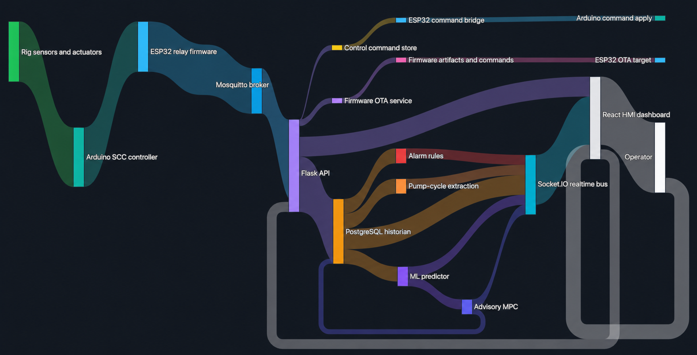
Fig 8. SCC database flow chart

Process Data Table
The telemetry table serves as the primary repository for process measurements and controller status information. Each telemetry record represents a complete snapshot of system operation at a specific point in time, including temperature measurements, controller states, pump metrics, safety indicators, and operational events. This structure enables historical reconstruction of system behavior, alarm analysis, machine-learning model training, and development of advisory control strategies.

The telemetry table schema is summarized in Table 7.

Table 7. Telemetry table schema used for storage of process measurements, controller states, safety indicators, and pump-cycle metrics within the SCC platform.

Field | Type | Key | Description
id | SERIAL | Primary Key | Unique telemetry record identifier
created_at | TIMESTAMPTZ | Indexed | Timestamp when the telemetry sample was stored
site_id | VARCHAR(80) | Indexed | Site identifier
rig_id | VARCHAR(120) | Indexed | Test rig identifier
device_id | VARCHAR(120) | Indexed | ESP32 device identifier
mqtt_topic | VARCHAR(255) |  | MQTT topic associated with the received message
raw_payload | JSONB |  | Original MQTT payload stored for traceability and debugging
event | INTEGER |  | Event code generated by the controller
ms | INTEGER |  | Controller runtime in milliseconds
temp_c | DOUBLE PRECISION |  | Measured process temperature (°C)
adc | INTEGER |  | Raw analog-to-digital converter value
dtemp_c_per_s | DOUBLE PRECISION |  | Temperature rate of change (°C/s)
setpoint_c | DOUBLE PRECISION |  | Temperature setpoint (°C)
mode | INTEGER |  | Controller operating mode
heater_pwm | INTEGER |  | Heater PWM duty cycle command
heating | INTEGER |  | Heater active status flag
heater_lockout | INTEGER |  | Heater lockout status flag
pump_enabled | INTEGER |  | Pump enabled status flag
pump_allowed | INTEGER |  | Pump permission status flag
pump_on | INTEGER |  | Pump running status flag
motor_pwm | INTEGER |  | Pump motor PWM duty cycle
motor_on_ms | INTEGER |  | Pump activation duration (ms)
motor_period_ms | INTEGER |  | Pump cycle period (ms)
temp_before_pump_c | DOUBLE PRECISION |  | Temperature immediately before pump activation (°C)
min_temp_after_pump_c | DOUBLE PRECISION |  | Minimum temperature observed after pump activation (°C)
last_pump_drop_c | DOUBLE PRECISION |  | Temperature drop caused by the most recent pump cycle (°C)
recovery_time_s | DOUBLE PRECISION |  | Temperature recovery time following a pump cycle (s)
manual_kill | INTEGER |  | Manual emergency stop status flag
hard_kill | INTEGER |  | Hard safety shutdown status flag
uptime_s | INTEGER |  | Device uptime in seconds
Table 7. Telemetry table schema used for storage of process measurements, controller states, safety indicators, and pump-cycle metrics within the SCC platform.
The raw_payload field is stored as a PostgreSQL JSONB object to preserve the original MQTT message structure and provide traceability for debugging, validation, and future schema extensions.

Supporting Tables
In addition to the primary telemetry table, several supporting tables are used to manage events, alarms, firmware updates, machine-learning outputs, and control commands. These tables provide separation of concerns while maintaining relationships with the primary telemetry records.
Table 8. Supporting database tables and their functions.

Table | Purpose
events | Stores pump start, pump end, recovery, and hard-kill events
alarms | Stores active and cleared alarm records
pump_cycles | Stores pump-cycle recovery and temperature-drop statistics
devices | Tracks device identity, online status, heartbeat, and MQTT activity
mqtt_message_log | Stores received MQTT messages and validation status
ml_predictions | Stores machine-learning temperature predictions
mpc_recommendations | Stores advisory heater PWM recommendations
control_commands | Stores backend setpoint commands
firmware_devices | Tracks firmware status for connected devices
firmware_update_events | Logs firmware and OTA update events
firmware_artifacts | Stores uploaded firmware artifact metadata
firmware_commands | Stores firmware update commands and acknowledgements
Table 8. Supporting database tables and their functions.

Relationships
Relationships between tables are implemented using foreign-key references to maintain data integrity and support efficient querying of historical records. These relationships allow telemetry records to be linked with events, alarms, predictive models, firmware operations, and control actions.

The primary database relationships are summarized in Table 9.

Table 9. Database relationships used within the SCC platform.

Relationship | Description
events.telemetry_id -> telemetry.id | Links an event to the telemetry sample that produced it
alarms.telemetry_id -> telemetry.id | Links an alarm to the telemetry sample that triggered it
ml_predictions.telemetry_id -> telemetry.id | Links ML predictions to the source telemetry sample
firmware_update_events.device_id -> firmware_devices.device_id | Links firmware events to a firmware device
firmware_commands.artifact_id -> firmware_artifacts.id | Links firmware commands to uploaded firmware artifacts
Table 9. Database relationships used within the SCC platform.

Data Indexing Strategy
Database indexes are applied to frequently queried fields to improve query performance for dashboard visualization, historical analysis, alarm investigation, and device monitoring. Indexed columns are selected based on expected filtering and retrieval operations.

Column | Purpose
created_at | Time-series queries and trend analysis
site_id | Site-level filtering
rig_id | Rig-level filtering
device_id | Device history and device-specific searches
event | Event analysis and diagnostics
hard_kill | Safety event investigation

Table 10. Database indexing strategy.

Data Retention Policy
A structured data-retention policy is recommended to balance long-term analytical value with database storage requirements. Raw telemetry data are retained for operational monitoring, model training, and fault analysis, while summary records and critical system events are preserved for long-term historical reference.

The recommended retention policy is summarized in Table 11.

Data Type | Retention
Raw telemetry | 30 to 90 days
Events and alarms | 1 year
Pump-cycle summaries | Long-term retention
ML predictions and MPC recommendations | 90 days
MQTT message logs | 7 to 30 days
Firmware update events | Long-term retention
Table 11. Recommended database retention policy.
To ensure data integrity and disaster recovery capability, database backups should be performed on a regular schedule using PostgreSQL backup utilities. For production deployments, daily database backups and weekly archived snapshots are recommended. Additional off-site backup storage may be implemented for enhanced system resilience and long-term record preservation.

Control System Design

Control Objectives
The SCC platform is designed to regulate solution temperature during stress-corrosion-cracking (SCC) testing while maintaining safe and stable operation during heating, fluid circulation, and long-duration experiments. The control system combines closed-loop temperature regulation, pump-aware compensation, and firmware-level safety mechanisms to ensure reliable operation under varying thermal conditions.

The primary control objectives are summarized in Table 12.

Objective | Description
Maintain setpoint temperature | Control the heater output to reach and hold the target bath temperature.
Prevent overheating | Disable heating when the temperature approaches unsafe limits.
Minimize thermal oscillation | Use PID control and ramped setpoints to reduce overshoot and unstable cycling.
Compensate for pump disturbance | Add heater bias before and during pump operation to reduce temperature drop.
Ensure safe operation | Apply heater lockout, hard-kill logic, and runtime limits in firmware.
Table 12. Control objectives implemented within the SCC platform.

Current Control Architecture
The primary control loop is executed locally within the Arduino controller firmware. Temperature measurements are acquired through the NTC thermistor and used to generate heater PWM commands. The ESP32 functions as a communication gateway, forwarding telemetry and command messages between the controller and backend infrastructure. Higher-level functions, including data storage, alarm generation, machine-learning prediction, and advisory model predictive control (MPC), are executed within the backend system.

The current control architecture is summarized in Table 13.

Control Feature | Implementation
Main controller | Arduino firmware
Communication bridge | ESP32 relay
Control output | Heater PWM
Feedback input | Temperature sensor through ADC
Control interval | 700 ms
Final setpoint | 125.00 °C
Heater PWM maximum | 200
Hard-kill temperature | 130.00 °C
Heater lockout high threshold | 128.50 °C
Heater lockout reset threshold | 126.50 °C
Table 13. SCC control system configuration.
This architecture ensures that critical control and safety functions remain operational even if communication with the backend is interrupted.

Control Modes
The controller operates as a finite-state system consisting of multiple control modes that support autotuning, temperature regulation, and safety management. During startup, the controller performs relay-based autotuning to estimate PID parameters. Once tuning is completed, the controller transitions to PID-based operation and maintains the target process temperature.

The available control modes are summarized in Table 14.
Mode | Description
Autotune warmup | Heater warms the system until it reaches the autotune region.
Autotune relay | Relay cycling is used to estimate PID tuning parameters.
PID ramp | The active setpoint ramps gradually from the autotune target to the final setpoint.
PID hold | The controller holds the final setpoint using PID control.
Safety override | Heating is disabled during hard kill, manual kill, or heater lockout conditions.
Table 14. Controller operating modes.
The controller automatically transitions between modes based on measured temperature, tuning completion status, and safety conditions.

Safety Logic
Safety functions are implemented directly within the controller firmware to ensure protection independent of the database, dashboard, network connection, machine-learning models, or backend services. Firmware-level protection guarantees that unsafe operating conditions result in immediate corrective action regardless of external system status.

The implemented safety mechanisms are summarized in Table 15.

Safety Function | Trigger | Action
Heater lockout | Temperature >= 128.50 °C | Heater output disabled
Lockout reset | Temperature <= 126.50 °C | Heater may resume
Hard kill | Temperature >= 130.00 °C | Heater and pump are disabled
Manual kill | Operator or external safety input | Control recommendation forced to zero
Runtime limit | 96 hours | Heater and pump disabled
Table 15. Firmware safety functions.
The machine-learning and MPC systems operate exclusively in an advisory capacity and shall not be considered part of the primary safety layer.

Pump Aware Compensation.
Pump operation introduces a predictable thermal disturbance by circulating cooler fluid through the test system. To reduce temperature excursions caused by pumping events, the controller applies anticipatory heater bias both before and during pump operation.

The pump compensation parameters are summarized in Table 16.

Parameter | Value | Description
Pump period | 30000 ms | Pump cycle interval
Pump on time | 1000 ms | Pump active duration
Pre-bias window | 5000 ms | Heater bias starts before pump activation
Pre-bias PWM | +18 | Extra heater PWM before pump operation
Pump-on bias PWM | +28 | Extra heater PWM while pump is running
Table 16. Pump-aware compensation settings.
To reduce integral windup caused by predictable disturbances, the PID integrator is temporarily frozen while the pump is active.

Advisory Model Predictive Control (MPC)
An advisory Model Predictive Control (MPC) module is implemented within the backend architecture to evaluate future control actions and provide operator guidance. The MPC module does not directly control the heater; instead, it evaluates candidate heater PWM values and recommends an optimal action based on predicted thermal response.

Current MPC Status: Advisory Only

Future MPC Status: Closed-Loop Control Following Validation and Safety Review

The current MPC implementation is summarized in Table 17.

MPC Feature | Description
Candidate PWM values | 0, 64, 128, 184, 220, 255
Prediction horizon | 5 seconds
Model source | `best_model_5s.joblib` if available
Fallback behavior | Uses a simple predictor when no ML model exists
Safety override | Recommends PWM 0 during hard kill, manual kill, or heater lockout
Table 17. Advisory MPC configuration
The MPC cost function minimizes temperature error while penalizing excessive control effort and abrupt changes in heater output:
$$cost = {\left(predicted_{temp}-setpoint_{c}\right)}^{2}+0.0005*pwm^{2}+0.05*(pwm - previous_{pwm})²$$

Machine Learning Roadmap
Model source: best_model_5s.joblib if available, generated using Scikit-learn and XGBoost model pipelines [11,12]. ML models provide temperature forecasting and anomaly detection capabilities that support process monitoring and future control-system enhancements. All ML outputs are advisory and do not override firmware-level safety protections.

Planned ML applications are summarized in Table 18.
Application | Purpose
Process Prediction | Forecast future process temperatures over short time horizons
Fault Detection | Identify abnormal heater, pump, or sensor behavior
Anomaly Detection | Detect unusual telemetry patterns during operation
Predictive Maintenance | Estimate equipment degradation using historical trends
MPC Support | Provide future temperature predictions for advisory MPC calculations
Table 18. Machine-learning applications within the SCC platform.
Current prediction horizons include short-term forecasts of +1 s, +5 s, and +10 s when trained models are available. Future development will focus on model validation, uncertainty quantification, adaptive control integration, and eventual deployment of closed-loop predictive control strategies.

Safety Analysis
The SCC control platform is designed so safety-critical decisions remain on the hardware side of the system. The Arduino controller and electrical interlocks own heater and pump shutdown behavior. The ESP32, Flask backend, database, HMI, ML model, and MPC service provide communication, monitoring, logging, alarms, and advisory recommendations only.

Backend alarms and dashboard notifications improve operator visibility, but they are not the primary protection layer. The rig must remain safe if the network, MQTT broker, database, server, HMI, ML model, or MPC endpoint fails.

Hazards
A hazard assessment was performed to identify potential failure modes, their consequences, and existing mitigation measures. The identified hazards are summarized in Table 19.

Hazard | Potential Consequence | Existing Mitigation
Bath overheating | Equipment damage, accelerated corrosion, unsafe test conditions, or operator burn hazard | Firmware heater lockout at 128.5 °C, hard kill at 130.0 °C, heater PWM limiting, and backend high-temperature alarms
Thermistor failure or invalid ADC reading | Incorrect temperature feedback resulting in uncontrolled heating | Sensor fault detection, ADC validation checks, heater shutdown, pump shutdown, lockout activation, and alarm generation
Pump failure or blocked flow | Poor solution circulation, invalid test results, and delayed thermal recovery | Pump telemetry monitoring, recovery-time analysis, and backend alarm generation
Pump operation without sufficient thermal headroom | Excessive temperature drop below operating conditions | Temperature-gated pump operation with configurable upper and lower thresholds
Heater output failure or excessive PWM command | Thermal runaway and equipment damage | Firmware lockout logic, hard-kill protection, PWM limiting, and recommended independent power isolation
Manual emergency shutdown | Delayed operator response during abnormal conditions | Manual kill command and provision for physical emergency-stop hardware
Network, MQTT, server, database, or HMI failure | Loss of monitoring, alarms, and remote control capability | Local firmware continues operation independently of backend services
ML or MPC recommendation error | Unsafe recommendation if treated as direct control action | MPC remains advisory only and cannot override firmware safety logic
Firmware update interruption | Uncertain controller state during firmware update operations | OTA preparation disables heater and motor outputs before reset
Excessive runtime or unattended operation | Continued operation beyond intended test duration | Firmware runtime limit and automatic shutdown functionality
Table 19. Hazard analysis and mitigation measures.

Safety Features
Multiple independent safety mechanisms are implemented within the SCC platform to prevent unsafe operation and reduce risk associated with hardware faults, software faults, and operator error.
The primary safety functions are summarized below:
- Heater Lockout: Heater output is disabled when measured temperature reaches 128.5 °C. Heating may resume only after temperature decreases below 126.5 °C.
- Hard Kill Protection: At 130.0 °C, the controller immediately disables heater and pump outputs, clears control commands, resets the PID integrator, activates lockout status, and generates a hard-kill event.
- Manual Kill Function: Operator-issued kill commands immediately disable heater and pump outputs and prevent further actuation until reset.
- Sensor Fault Detection: Invalid ADC values and thermistor fault conditions automatically disable all outputs and generate a fault event.
- Safe Startup Sequence: Heater and motor outputs remain disabled during initialization until controller state validation is complete.
- Pump Temperature Gating: Pump operation is permitted only within an approved temperature operating window.
- PWM Limiting: Heater PWM commands are constrained to a configurable maximum value to prevent excessive power output.
- PID Windup Protection: Integral accumulation is reset during lockout, hard-kill, manual-kill, and sensor-fault conditions.
- Safe OTA Preparation: Firmware update procedures disable all outputs before initiating reset or programming operations.
- Alarm Logging and Audit Trail: Critical safety events are recorded within the database and displayed through the HMI.
- Advisory-Only MPC: Model-based recommendations are prevented from overriding firmware safety states

Emergency Shutdown Procedure
In the event of abnormal operation or a hazardous condition, the following emergency shutdown procedure shall be performed:
- Emergency shutdown order should issue a manual kill before disconnecting power only if HMI is available; otherwise, disconnect power first.
- Disconnect the power
- Verify that heater PWM output is zero and heater power is electrically isolated.
- Verify that all pump and motor outputs are disabled.
- Allow the bath temperature to decrease below the lockout reset threshold.
- Record the event, including timestamp, measured temperature, active alarms, and operator actions.
- Inspect the heater assembly, thermistor, pump system, power electronics, and enclosure for damage or abnormal conditions.
- Restart operation only after the root cause has been identified and corrective actions have been completed.

Safety verification Tests
Safety functions shall be validated through functional testing before deployment. Verification tests are summarized in Table 20.

Safety Function | Test Method | Expected Result
Safe Startup | Power cycle controller while monitoring outputs | Outputs remain disabled during initialization
Heater Lockout | Raise temperature to 128.5 °C | Heater output disabled and lockout activated
Lockout Recovery | Reduce temperature below 126.5 °C | Lockout clears and normal operation resumes
Hard Kill | Simulate temperature ≥ 130.0 °C | Heater and pump disabled; hard-kill event generated
Sensor Fault Detection | Simulate open-circuit or short-circuit thermistor | Outputs disabled and fault event generated
Manual Kill | Issue kill command through communication interface | Heater and pump immediately disabled
Pump Temperature Gating | Test operation at threshold temperatures | Pump operates only within permitted temperature range
Runtime Limit | Simulate 96-hour runtime condition | Heater and pump automatically disabled
Backend Alarm Path | Inject alarm-triggering telemetry data | Correct alarm generation and logging
MPC Safety Override | Request recommendation during safety event | Recommended PWM returns zero
Table 20. Safety verification tests.

Residual Risk and Recommendation
Although multiple layers of protection are implemented, certain residual risks remain and should be addressed prior to unattended or production operation.
- Installation of a physical emergency-stop device or independent power disconnect is strongly recommended.
- Thermistor calibration and fault-detection thresholds should be validated experimentally using open-circuit, short-circuit, and elevated-temperature conditions.
- Heater MOSFET, relay, or power-stage failures may bypass software control; independent over-temperature protection and fused power isolation should be considered.
- Network failures eliminate remote visibility and alarm reporting; local indicators and periodic operator inspection remain necessary.
- OTA firmware update functionality should remain restricted until complete hardware validation has been performed.
- Any future implementation of closed-loop MPC control shall require a dedicated safety review, cybersecurity review, and verification that firmware safety mechanisms cannot be bypassed.
The safety architecture implemented within the SCC platform ensures that hazardous conditions are mitigated through local firmware protection mechanisms while maintaining operational visibility through backend monitoring, alarm management, and data logging services.

Verification and Validation

Verification and Validation Overview
Verification and validation activities were developed to evaluate the functionality, reliability, and safety of the SCC platform. Verification focuses on confirming that individual software modules, firmware functions, communication interfaces, and safety mechanisms perform according to their design requirements. Validation focuses on demonstrating that integrated subsystems operate correctly when deployed as a complete platform.
The SCC platform repository currently contains automated unit tests covering firmware logic, ESP32 relay parsing, backend telemetry processing, alarm generation, firmware management functions, API authentication, and advisory MPC safety behavior. In addition, the repository includes manual integration procedures for telemetry-path validation and dedicated hardware test projects for thermistor, heater, and motor verification.
The verification matrices presented in this section include only tests and validation procedures that currently exist within the repository. Planned activities that have not yet been implemented, including dashboard automation testing, heartbeat monitoring validation, long-duration endurance testing, and full commissioning activities, are excluded from the formal verification record and are identified separately as future work.

Unit Tests
Unit testing is used to verify individual firmware and software functions in isolation before subsystem integration. These tests evaluate temperature measurement, safety logic, pump control, telemetry generation, communication parsing, backend processing, firmware management, and MPC advisory functions.
The implemented unit test matrix is summarized in Table 21.
Test ID | Description | Expected Result | Status
UT-001 | Temperature conversion and ADC calibration | ADC values are converted to expected temperature values using the calibrated transfer function | Implemented
UT-002 | ADC sensor fault detection | Open-circuit and short-circuit ADC rail values are detected with recovery hysteresis | Implemented
UT-003 | Pump temperature gating | Pump permission enables only with thermal headroom and disables at low or high temperature limits | Implemented
UT-004 | Pump PWM timing | Pump startup kick, run PWM, and off timing follow the configured motor cycle | Implemented
UT-005 | Motor timer and heater pre-bias logic | Motor cycle phase and heater bias windows are calculated correctly | Implemented
UT-006 | Autotune and PID state logic | Autotune transitions, timeout behavior, PID first-sample behavior, ramp completion, and lockout output suppression work as expected | Implemented
UT-007 | Telemetry CSV schema | Telemetry header column count and column order match the expected schema | Implemented
UT-008 | Bootloader entry command parsing | Supported bootloader preparation commands are accepted and unrelated commands are rejected | Implemented
UT-009 | ESP32 relay CSV parsing | Arduino CSV telemetry rows are parsed into the relay snapshot fields correctly | Implemented
UT-010 | ESP32 relay backend command parsing | Supported backend command types are parsed and unsupported commands are rejected | Implemented
UT-011 | Backend telemetry parser | Headerless and header-based CSV telemetry rows are parsed and invalid rows are rejected | Implemented
UT-012 | Backend alarm rules | Hard kill, manual kill, heater lockout, sensor fault, high temperature, slow recovery, and excessive cooling alarms are generated correctly | Implemented
UT-013 | Backend API authentication | Protected telemetry write endpoints reject missing keys and accept valid API key formats | Implemented
UT-014 | Firmware API validation and command queue | ESP32 and Arduino firmware file types are validated and queued commands can be acknowledged | Implemented
UT-015 | MPC safety override | MPC recommendations return zero PWM during hard kill, manual kill, or heater lockout states | Implemented
Table 21. Implemented unit tests for SCC firmware, ESP32 relay services, backend services, and MPC logic.
Successful execution of these tests verifies that the individual software and firmware components operate according to their intended design requirements and interface specifications.

Integration and Hardware Validation Procedures
Integration testing verifies communication and interoperability between embedded controllers, communication services, backend infrastructure, and database storage systems. Hardware validation procedures are used to confirm operation of physical components, including temperature sensing, heater control, and pump actuation.
The integration and hardware validation procedures currently implemented within the repository are summarized in Table 22.
Test ID | Description | Expected Result | Status
IT-001 | Arduino telemetry to ESP32 relay parsing | ESP32 receives deterministic Arduino CSV rows and parses them with the relay core parser | Manual procedure defined
IT-002 | ESP32 telemetry relay to Flask API | ESP32 posts parsed telemetry JSON to the Flask telemetry endpoint | Manual procedure defined
IT-003 | Flask telemetry ingestion to PostgreSQL | Stored PostgreSQL rows match the source Arduino CSV fixture | Manual verifier implemented
IT-004 | End-to-end telemetry pipeline | Data propagate from Arduino test firmware through ESP32 and Flask into PostgreSQL | Manual procedure defined
IT-005 | Backend-only telemetry pipeline smoke test | Sample CSV rows are posted directly to Flask and verified against PostgreSQL without hardware | Scripted verifier implemented
IT-006 | Standalone NTC temperature readout | Arduino reads thermistor ADC values and prints live temperature CSV rows | Manual hardware test project defined
IT-007 | Standalone heater control test | Arduino heater test accepts start/stop commands, limits PWM, and reports hard-kill status | Manual hardware test project defined
IT-008 | Standalone motor output test | Arduino motor test accepts start/stop commands and reports PWM output state | Manual hardware test project defined
Table 22. Implemented integration tests and hardware validation procedures.
These procedures provide verification of data flow through the telemetry pipeline, communication between hardware and software subsystems, database storage integrity, and operation of critical hardware components. Together, they establish confidence that the individual subsystems can function as an integrated SCC platform.

Current Verification Coverage Gaps
Although significant verification coverage has been implemented, several system-level validation activities remain outside the current repository scope. These items represent future verification work that should be completed before deployment in a production or long-duration testing environment.
The repository does not currently include automated verification for dashboard live-update functionality, MQTT broker transport validation, heartbeat and offline-device detection, complete HMI-to-controller manual-kill routing, or full system commissioning and endurance testing. These activities should remain classified as future validation tasks until formal test procedures, execution records, and acceptance criteria have been developed.
Future verification efforts should also include extended-duration operational testing, failure-recovery testing, network-loss testing, and final acceptance testing of the fully integrated SCC platform.

Verification Summary
The SCC platform currently includes implemented verification activities covering firmware control logic, safety mechanisms, telemetry generation, communication parsing, backend processing, firmware management, and advisory MPC behavior. Additional integration procedures and standalone hardware validation projects have been developed to support verification of communication pathways and physical hardware operation.
The existing verification framework provides a foundation for future system-level validation and commissioning activities while demonstrating that the major software, firmware, and hardware subsystems have defined verification procedures and measurable acceptance criteria.

Deployment Guide

Deployment Overview
The SCC platform is deployed using a containerized architecture based on Docker and Docker Compose [6] consisting of a Flask backend, React Human–Machine Interface (HMI), PostgreSQL database, MQTT broker, and optional Cloudflare Tunnel service. Docker Compose is used to simplify deployment and ensure consistent configuration across development and production environments.
The deployment architecture supports local operation on a single workstation or distributed deployment across multiple networked systems. The ESP32 communication gateway publishes telemetry data through MQTT, while backend services process, store, and visualize operational data.

Server Requirements
The deployment server must provide sufficient computing resources to support the backend API, database services, MQTT communication, dashboard visualization, and future machine-learning workloads.
Operating System: Ubuntu Server Lite
Processor: Intel NUC
Memory: 4 GB RAM
Storage: 128GB
Network: The deployment server must be reachable by the ESP32 communication gateway. Required ports include:
Service | Port
MQTT Broker | 1883
Backend API | 5050
Frontend Dashboard | 5173
PostgreSQL | 5432
Table 23. Network Ports
Software Requirements:
- Docker Engine or Docker Desktop
- Docker Compose
- Python 3.11 (non-Docker deployment)
- Node.js 22 (non-Docker deployment)
- PostgreSQL
- Eclipse Mosquitto MQTT Broker

Containerized Services
The SCC platform is composed of multiple Docker services that provide communication, data storage, visualization, firmware management, and predictive analytics capabilities.

Service | Image or Build Source | Port | Purpose
Backend | backend/Dockerfile using Python 3.11-slim | 5050:5000 | Runs the Flask API, MQTT subscriber, telemetry parser, alarm engine, ML prediction services, MPC advisory logic, and firmware management APIs
Frontend | node:22-alpine | 5173:5173 | Provides the React/Vite HMI dashboard for monitoring, alarms, trends, settings, firmware management, and analytics
PostgreSQL | postgres:16 | 5432:5432 | Stores telemetry, alarms, events, pump-cycle records, predictions, commands, and configuration data
MQTT Broker | eclipse-mosquitto:2 | 1883:1883, 9001:9001 | Provides MQTT and MQTT-over-WebSocket communication services
Cloudflare Tunnel | cloudflare/cloudflared:latest | Outbound Tunnel | Optional secure remote-access service
Table 24. Docker services used within the SCC platform deployment.

Deployment Procedure
The following procedure is used to deploy the SCC platform using Docker Compose.
Step 1 – Obtain the Source Repository
git clone <repository-url>
cd scc-control-platform
Step 2 – Create the Environment Configuration File
cp .env.example .env
Step 3 – Configure Environment Variables
The minimum required configuration is shown below.
API_WRITE_KEY=<shared-write-key-for-backend-and-dashboard>
CORS_ORIGINS=http://localhost:5173
PUBLIC_BASE_URL=http://localhost:5050
MQTT_HOST=mosquitto
MQTT_PORT=1883
MQTT_BASE_TOPIC=scc
If email notifications are enabled, SMTP configuration parameters must also be defined.
Step 4 – Start Platform Services
docker compose up --build
Step 5 – Verify Service Status
docker compose ps
Step 6 – Verify Application Access
Backend API: http://localhost:5050
Frontend HMI: http://localhost:5173
PostgreSQL: localhost:5432
MQTT Broker: localhost:1883
Step 7 – Configure ESP32 Communication Gateway
Update the ESP32 firmware configuration to match the deployment environment.
#define MQTT_BROKER_URI "mqtt://<server-lan-ip>:1883"
#define MQTT_BASE_TOPIC "scc"
#define MQTT_SITE_ID "site-01"
#define MQTT_RIG_ID "rig-01"
#define MQTT_DEVICE_ID "esp32-relay-01"
Step 8 – Verify Telemetry Communication
Confirm that telemetry messages are received by the backend and appear within the dashboard.
GET http://localhost:5050/api/latest
Step 9 – Execute Verification Procedures
Prior to operation, execute available automated verification tests.
pytest backend/tests
pio test -d firmware/arduino/SCC-V1.4 -e native
pio test -d firmware/esp32/ESP32-Relay -e native
Step 10 – Configure Optional Remote Access
For remote access deployments, configure the Cloudflare Tunnel token to enable secure external access without direct port exposure [13] within the environment configuration file.
CLOUDFLARE_TUNNEL_TOKEN=<cloudflare-token>
After deployment, verify that public endpoints correctly route traffic to the backend API and HMI dashboard.

Post-Deployment Verification
Following deployment, a series of checks should be performed to confirm proper system operation.

Check | Expected Result
Backend Health | Backend responds successfully on http://localhost:5050
Dashboard Access | HMI dashboard loads on http://localhost:5173
Database Startup | PostgreSQL container reports healthy status
MQTT Connectivity | ESP32 successfully connects to the MQTT broker
Telemetry Reception | /api/latest returns current telemetry data
Alarm Functionality | Active alarms appear within API responses and dashboard views
Manual Kill Command | Authenticated kill commands can be issued successfully
Data Persistence | PostgreSQL data remain available following container restart
Table 25. Post-deployment verification checklist.
Successful completion of the post-deployment verification checklist indicates that the SCC platform has been deployed correctly and is ready for hardware integration, system validation, and operational testing.

Operations Guide

Startup Procedure
Before operation, the SCC platform shall be inspected to verify that all mechanical, electrical, thermal, and communication systems are functioning correctly. The startup procedure ensures that the specimen, heating cell, circulation system, sensors, and control electronics are prepared for safe operation before heating is enabled.
The startup procedure shall be performed in the order listed below.
- Wear personal protective equipment (PPE): Gloves and Safety glasses.
- Mount the test specimen securely within the test fixture.
- Apply RTV sealant around the copper cell sealing surfaces as required.
- Install and secure the copper heating cell.
- Connect the pump outlet tubing to the copper cell.
- Connect the exhaust tubing to the copper cell.
- Verify that the MgCl₂ reservoir contains sufficient solution for the planned test duration.
- Verify that the pump intake tubing remains fully submerged below the fluid surface.
- Verify thermistor and temperature sensor connections.
- Verify heater wiring and heater cartridge installation.
- Verify all control electronics, power connections, and communication cables.
- Apply power to the SCC platform.
- Verify network connectivity between the ESP32 gateway and backend services.
- Allow the control system to complete initialization and startup checks.
- Verify dashboard status indicators and confirm receipt of live telemetry.
Successful completion of the startup procedure indicates that the SCC platform is ready for operation.

Corrosive Medium Preparation and Handling
The SCC platform utilizes a magnesium chloride (MgCl₂) solution as the corrosive medium for stress-corrosion-cracking experiments. Proper preparation of the solution is required to ensure repeatable test conditions and consistent corrosion behavior.
Solution Composition
The standard corrosion solution used for SCC testing is summarized in Table 26.
Parameter | Value
Chemical | Magnesium Chloride Hexahydrate (MgCl₂·6H₂O)
Solution Concentration | 30 wt.% MgCl₂
MgCl₂·6H₂O Mass | 500 g
Deionized Water Volume | 280 mL
Typical Operating Temperature | 125 °C
Table 26. Standard MgCl₂ corrosion solution.
Preparation Procedure
- Wear personal protective equipment (PPE): ideally, safety glasses, gloves, and a mask.
- Verify that a clean mixing container is available.
- Measure 280 mL of deionized (DI) water.
- Add 500 g of magnesium chloride hexahydrate (MgCl₂·6H₂O) to the container.
- Slowly add the DI water while stirring continuously.
- Continue mixing until all visible solids are dissolved and a uniform solution is obtained.
- Allow the solution to stabilize before transferring it to the SCC reservoir.
- Verify that the reservoir contains sufficient solution volume before beginning operation.

Operator Responsibilities and Monitoring Requirements
During operation, the operator is responsible for maintaining safe operating conditions, monitoring system performance, and responding to alarms or abnormal conditions.

Operator Responsibilities
- Confirm that the SCC rig is physically safe to operate before enabling heat or pump activity.
- Keep the HMI dashboard open throughout testing and verify that telemetry updates continuously.
- Monitor bath temperature, temperature error, heater PWM, pump status, and controller operating mode.
- Verify that the system remains within the intended operating temperature range.
- Confirm that heater lockout, manual kill, and hard-kill indicators remain inactive during normal operation.
- Verify that pump cycles occur only when sufficient thermal headroom is available.
- Review active alarms and event timeline entries throughout each operating session.
- Treat machine-learning predictions and MPC recommendations as advisory information only.
- Record abnormal behavior, alarms, operator actions, and shutdown events in the test log.
- Immediately stop testing if unsafe operating conditions are observed.

Monitoring Requirements
The following parameters shall be monitored during active operation:
- Process temperature, setpoint temperature, and temperature error.
- Heater PWM command and heater operating state.
- Pump status, motor PWM, pump recovery time, and pump-cycle temperature drop.
- Active alarm status and alarm history.
- Event timeline entries, including pump start, pump stop, pump recovery, hard-kill, and sensor-fault events.
- MQTT connectivity and dashboard update status.
- Database logging status and telemetry history availability.
Operators shall remain in the vicinity of the test system during active heating unless approved unattended-operation procedures and independent physical safety systems are in place.
Any abnormal noise, fluid leakage, overheating, unexpected pump behavior, unusual odor, electrical fault indication, or loss of telemetry shall require immediate investigation and possible shutdown.

Alarm Response Procedures
The SCC platform generates alarms to notify operators of abnormal operating conditions. Critical alarms require immediate corrective action, while warning alarms require increased monitoring and investigation.

Alarm | Severity | Operator Response
HARD_KILL | Critical | Treat as an emergency shutdown. Verify heater PWM is zero, verify pump output is disabled, allow cooling, inspect hardware, and determine root cause before restart.
MANUAL_KILL | Critical | Confirm shutdown was intentional. Maintain disabled state until inspection is complete and restart conditions are met.
SENSOR_FAULT | Critical | Stop operation, inspect thermistor wiring and ADC input, verify temperature independently if possible, and restart only after valid telemetry is restored.
HIGH_TEMP_CRITICAL | Critical | Disable heating immediately, allow cooling, and inspect heater and temperature-control hardware.
HEATER_LOCKOUT | Warning | Continue monitoring while heating remains disabled. Resume operation only after temperature falls below the reset threshold.
HIGH_TEMP_WARNING | Warning | Monitor temperature trend and heater output closely. Prepare for shutdown if temperature continues increasing.
SLOW_RECOVERY | Warning | Inspect pump operation, fluid flow path, mixing performance, and thermal recovery characteristics.
EXCESSIVE_PUMP_COOLING | Warning | Verify pump timing, flow rate, solution temperature, and compensation settings.
Table 27. Alarm response procedures.
If any critical alarm occurs, operator safety and equipment protection shall take priority over test completion or data collection. Testing shall remain suspended until the root cause has been identified and corrective action has been completed.

Shutdown Procedure
The SCC platform shall be shut down in a controlled manner to prevent equipment damage, fluid spills, and unnecessary exposure to heated MgCl₂ solution.
The shutdown procedure shall be performed in the order listed below.
- Wear all required personal protective equipment (PPE).
- Issue the manual kill command through the HMI or controller interface.
- Disconnect power from the SCC platform.
- Disconnect the intake tubing from the pump and allow residual solution to drain.
- Disconnect the pump outlet tubing from the copper cell and return residual solution to the reservoir.
- Remove the copper cell assembly from the specimen.
- Remove the test specimen from the fixture.
- Clean the copper cell, tubing, specimen, and work area.
- Inspect the system for corrosion, leaks, damaged wiring, or abnormal wear.
- Record test completion details, observations, alarms, and maintenance actions in the test log.
Successful completion of the shutdown procedure returns the SCC platform to a safe, de-energized condition suitable for storage, maintenance, or preparation for the next test.

Maintenance Manual

Maintenance Overview
Routine maintenance is required to ensure reliable operation of the SCC platform and to minimize the risk of equipment failure, inaccurate measurements, communication interruptions, and unsafe operating conditions. Maintenance activities are divided into preventive maintenance and corrective maintenance. Preventive maintenance consists of scheduled inspections and verification activities intended to identify potential issues before failure occurs. Corrective maintenance is performed in response to alarms, faults, abnormal system behavior, or equipment malfunction.
All maintenance activities should be recorded in the system maintenance log, including inspection dates, observations, corrective actions, replacement parts, and personnel performing the work.

Preventive Maintenance
Preventive maintenance shall be performed according to the schedule shown in Table 27. These activities are intended to verify proper operation of sensing, heating, pumping, communication, and data-management systems before faults occur.

Item | Frequency
Temperature sensor inspection | Daily
Heater and pump status check | Daily
SCC test cell inspection | Daily
Wiring and connector inspection | Weekly
MQTT/backend connectivity check | Weekly
Database backup verification | Monthly
Firmware and configuration backup | Monthly
Alarm and manual kill function check | Monthly
Table 28. Preventive maintenance schedule.
Daily Inspection Requirements
- Inspect the thermistor and sensor wiring for damage, corrosion, or loose connections.
- Verify proper heater operation and confirm normal heating response.
- Verify pump operation and check for leaks, blockage, or abnormal noise.
- Inspect the SCC test cell for corrosion, contamination, fluid leakage, or physical damage.
- Verify that telemetry data are being reported correctly through the dashboard.
Weekly Inspection Requirements
The following items should be verified at least once per week:
- Inspect all electrical wiring, connectors, and terminal blocks.
- Verify MQTT communication between the ESP32 relay and backend services.
- Review alarm history for recurring faults or abnormal trends.
- Inspect tubing and fluid pathways for signs of wear, clogging, or degradation.
Monthly Inspection Requirements
The following items should be verified monthly:
- Confirm successful PostgreSQL database backups.
- Create backups of firmware images and system configuration files.
- Verify operation of manual kill, heater lockout, and hard-kill safety functions.
- Review system logs for persistent alarms, communication issues, or abnormal operating conditions.

Corrective Maintenance
Corrective maintenance shall be performed whenever a fault, alarm condition, communication failure, hardware malfunction, or abnormal operating condition is observed. The objective of corrective maintenance is to identify the root cause of the issue, restore normal operation, and prevent recurrence.
The recommended corrective actions for common fault conditions are summarized in Table 28.

Fault Condition | Corrective Action
Sensor fault | Inspect thermistor wiring, verify ADC readings, replace sensor if needed
Heater not responding | Check heater wiring, MOSFET/relay, power supply, PWM output, and firmware state
Pump not operating | Inspect pump wiring, motor driver, tubing, flow path, and motor PWM output
Excessive temperature | Stop operation, verify heater output is off, inspect sensor accuracy and heater control circuit
Telemetry loss | Check ESP32 power, Wi-Fi/MQTT connection, backend service, and broker status
Database logging failure | Check PostgreSQL container, disk space, backend logs, and database connection string
Dashboard not updating | Check backend API, frontend service, network connection, and browser console errors
Table 29. Corrective maintenance procedures.

Component Replacement Guidelines
When replacing components, power shall be removed from the system, and all heated surfaces shall be allowed to cool to a safe handling temperature. Replacement components shall meet the original design specifications and shall be verified through functional testing before returning the system to service.
The following components are considered field-replaceable:
- NTC thermistor temperature sensor
- Cartridge heater
- Pump and pump tubing
- ESP32 communication module
- Wiring harnesses and electrical connectors
- Power switching components, including relays and MOSFETs
Following replacement, a startup inspection and verification test shall be performed to confirm correct operation.

Maintenance Safety Considerations
Maintenance activities shall be performed only when the system is in a safe, de-energized condition. Operators shall wear appropriate personal protective equipment when handling heated components, corrosive solutions, electrical systems, or contaminated hardware.
Before performing maintenance:
- Issue a manual kill command if the system is operational.
- Disconnect system power.
- Allow the copper heating cell and associated hardware to cool.
- Drain or isolate MgCl₂ solution if fluid-handling components will be serviced.
- Verify that all heater and pump outputs are de-energized.
- Follow applicable laboratory safety procedures for chemical handling and disposal.

Troubleshooting Guide

Troubleshooting Overview
This section guides diagnosing and correcting common hardware, firmware, communication, database, and operational issues that may occur during SCC platform operation. Troubleshooting should be performed systematically, beginning with verification of safety conditions, power availability, sensor status, and communication connectivity before attempting more advanced diagnostics.
When investigating faults, operators should review active alarms, telemetry values, event logs, backend logs, and dashboard status indicators. If a critical alarm such as HARD_KILL, MANUAL_KILL, or SENSOR_FAULT is active, the system shall remain in a safe state until the root cause has been identified and corrected.
The troubleshooting matrix is summarized in Table 29
Issue | Possible Cause | Corrective Action
No temperature data | Thermistor disconnected, ADC input fault, Arduino not running, or ESP32 not forwarding telemetry | Inspect thermistor wiring, verify Arduino serial output, check ESP32 power, and confirm telemetry reaches the backend
Temperature value is unrealistic | Sensor calibration error, loose thermistor connection, ADC rail reading, or damaged sensor | Check ADC value, inspect wiring, compare with an independent thermometer, replace sensor if needed, and recalibrate
SENSOR_FAULT alarm active | Open-circuit or short-circuit sensor condition, missing temperature field, or invalid ADC data | Stop operation, inspect sensor circuit, restore valid readings, and restart only after the alarm clears
No MQTT data | Mosquitto broker offline, wrong broker IP, Wi-Fi issue, wrong MQTT topic, or ESP32 disconnected | Verify broker container is running, confirm ESP32 uses the server LAN IP, check Wi-Fi credentials, and confirm topic format
Backend not receiving telemetry | MQTT subscriber offline, backend container stopped, bad API key for HTTP test path, or malformed payload | Check backend logs, restart backend if needed, verify MQTT settings, and validate telemetry format
Dashboard not updating | Frontend cannot reach backend, backend API down, stale browser session, or telemetry not arriving | Open http://localhost:5050/api/latest, check frontend API URL, refresh the dashboard, and verify backend/container status
PostgreSQL logging failure | Database container unhealthy, wrong DATABASE_URL, schema not initialized, or disk full | Check docker compose ps, inspect database logs, verify connection string, confirm free disk space, and restart services if required
Heater disabled | Heater lockout, hard kill, manual kill, sensor fault, temperature above setpoint, or runtime limit reached | Check active alarms and telemetry flags, verify temperature limits, clear manual kill only after inspection, and allow cooling before restart
Heater does not heat when expected | PWM output disabled, MOSFET/relay fault, power supply issue, wiring fault, or failed heater | Verify heater PWM telemetry, inspect power electronics, measure output voltage safely, and test heater circuit before operation
Temperature rising too fast | Heater control fault, stuck MOSFET/relay, sensor reading low, or excessive heater power | Stop the test, verify heater output is de-energized, inspect sensor accuracy, and check heater driver hardware
Pump not running | Pump temperature gate disabled, motor driver fault, wiring fault, pump jam, manual kill, hard kill, or runtime limit | Check pump_allowed, pump_on, and motor PWM telemetry, inspect wiring and driver, and test the pump with the standalone motor test
Excessive pump cooling | Pump dose too large, solution too cold, flow path issue, poor thermal compensation, or incorrect pump timing | Inspect pump timing, flow rate, tubing, solution temperature, and review last_pump_drop_c telemetry
Slow recovery after pump cycle | Heater underpowered, poor mixing, pump disturbance too large, or thermal model mismatch | Check heater PWM, pump recovery time, bath mixing, and pump settings before continuing the test
HEATER_LOCKOUT alarm active | Temperature reached lockout threshold or lockout remains set after a fault | Keep heater disabled, allow bath to cool below reset threshold, inspect cause, and resume only if no critical alarm remains
HARD_KILL alarm active | Temperature reached hard-kill threshold or safety shutdown was triggered | Treat as emergency shutdown, verify heater and pump outputs are off, inspect hardware, and do not restart until root cause is found
MANUAL_KILL alarm active | Operator issued emergency off command or command remains latched | Confirm shutdown state, inspect rig, then release manual kill only when safe to resume
Manual kill command not received | API write key mismatch, ESP32 command polling stopped, backend command queue issue, or network failure | Verify API_WRITE_KEY and VITE_API_WRITE_KEY, check ESP32 polling endpoint, confirm backend is reachable, and inspect command queue logs
Firmware OTA command fails | Wrong firmware file type, unreachable firmware URL, missing reset wiring, bad OTA configuration, or device offline | Verify firmware type, check PUBLIC_BASE_URL, confirm device connectivity, and keep Arduino OTA disabled unless reset/programming path is tested
Email alerts not sent | Email alerts disabled, SMTP settings missing, bad credentials, or cooldown interval active | Check ALERT_EMAIL_ENABLED, SMTP variables, backend logs, and ALERT_EMAIL_COOLDOWN_SECONDS
Cloudflare/public URL not working | Missing tunnel token, tunnel container stopped, DNS route not configured, or service origin mismatch | Set CLOUDFLARE_TUNNEL_TOKEN, check tunnel logs, verify route configuration, and confirm backend/frontend are reachable locally
Tests fail to run | Python dependencies missing, PlatformIO not installed, wrong working directory, or hardware not connected | Install dependencies, run from scc-control-platform, use the documented pytest and pio test commands, and connect required test hardware
Table 30. SCC platform troubleshooting guide.

Troubleshooting Workflow
When a fault occurs, troubleshooting should follow the sequence below:
- Review active alarms displayed on the dashboard.
- Verify that the system is in a safe operating state.
- Confirm power availability and controller operation.
- Verify thermistor readings and telemetry updates.
- Check MQTT communication and backend connectivity.
- Verify database logging and dashboard operation.
- Review recent event logs and alarm history.
- Inspect associated hardware components.
- Correct the identified fault condition.
- Perform startup verification before resuming operation.
Following a consistent troubleshooting process helps minimize downtime and reduces the likelihood of overlooking related faults.

Escalation Criteria
Operation shall be suspended and the system removed from service if any of the following conditions occur:
- Repeated activation of the hard-kill protection system.
- Repeated sensor-fault alarms after sensor replacement.
- Evidence of overheating, smoke, electrical arcing, or damaged wiring.
- Fluid leakage from the SCC cell, tubing, or reservoir.
- Failure of heater lockout or manual kill functions.
- Corrupted database records or persistent telemetry loss.
- Any condition that could compromise operator safety or test validity.
The system shall not be returned to service until the root cause has been identified, corrective action has been completed, and normal operation has been verified.

References

[1] MQTT.org, "MQTT Version 5.0 Specification," MQTT.org, 2019.

[2] Javan Electronics, "ESP32 DOIT DevKit V1 Technical Reference Manual," Javan Electronics.

[3] Arduino, "Arduino Uno Rev3 Technical Specifications," Arduino Documentation.

[4] PostgreSQL Global Development Group, "PostgreSQL Documentation."

[5] Pallets Projects, "Flask Documentation."

[6] Docker Inc., "Docker Documentation."

[7] Eclipse Foundation, "Eclipse Mosquitto Documentation."

[8] Python Software Foundation, "Python 3.11 Documentation."

[9] SQLAlchemy Authors, "SQLAlchemy Documentation."

[10] Socket.IO Authors, "Socket.IO Documentation."

[11] XGBoost Contributors, "XGBoost Documentation."

[12] Scikit-learn Developers, "Scikit-learn Documentation."

[13] Cloudflare Inc., "Cloudflare Tunnel Documentation."

[14] Intel Corporation, "Intel NUC Technical Product Specifications."

[15] Microchip Technology Inc., "ATmega328P Datasheet."

